LLMOps — How to Build, Evaluate, Trace, and Improve AI Agents
In the first two parts of this series, we explored the foundations of AI Agents.
We learned that an AI Agent combines:
LLM + Tools + Memory + RAG + Planning + Actions + Feedback
We also saw how an agent uses loops to perform complex tasks.
But there is one final challenge:
How do we make an AI Agent reliable when it is used in the real world?
An experimental agent may work once or twice.
A production agent needs much more.
It needs:
- Evaluation
- Monitoring
- Tracing
- Cost management
- Security
- Reliability
- Deployment
- Continuous improvement
This is where LLMOps becomes important.

1. What Is LLMOps?
LLMOps refers to the operational practices required to manage AI systems, particularly systems using large language models, after they move beyond experimentation.
When an AI system moves into production, developers need to continuously monitor and improve it.
LLMOps can involve:
- Model management
- Prompt management
- Evaluation
- Monitoring
- Tracing
- Cost management
- Latency optimization
- Version control
- Deployment
- Data management
- Security
- Reliability
Therefore:
Building an AI Agent is not just writing a prompt. It is a complete engineering process.

2. Why Evaluation Is Important
Suppose you build an AI research agent.
You test it once. It produces an excellent report.
Does that prove the agent works reliably?
No.
A single successful demonstration is not enough.
Developers can instead create evaluation datasets containing different test cases and evaluate the agent systematically.
Developers can instead create evaluation datasets containing different test cases and evaluate the agent systematically.
Possible evaluation metrics include:
- Accuracy
- Relevance
- Factual correctness
- Hallucination
- Task completion
- Tool selection accuracy
- Retrieval quality
- Latency
- Cost
Evaluation allows developers to compare different versions of an agent and identify regressions.

3. Example of Agent Evaluation
Imagine an AI research agent receives 100 research questions.
We can evaluate:
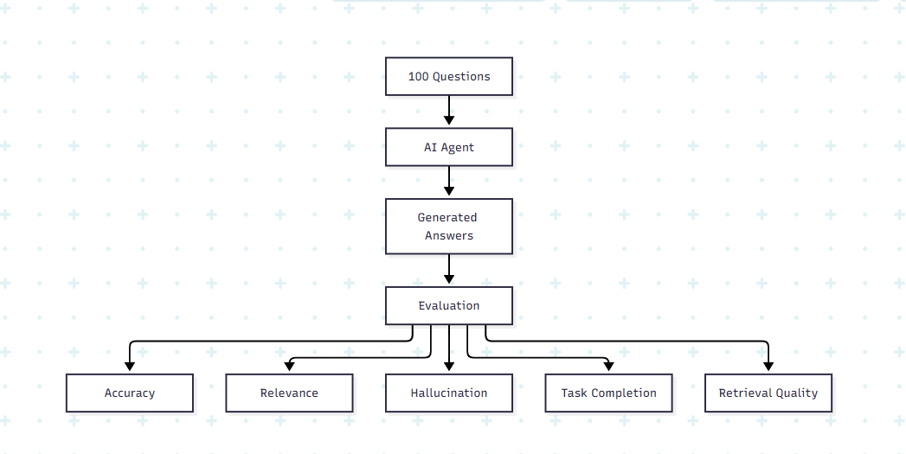
This helps developers understand where the system performs well and where improvements are needed.

4. What Is Tracing?
Suppose your agent gives an incorrect answer.
Looking only at the final answer may not reveal the problem.
Maybe:
- The search tool returned poor information.
- RAG retrieved the wrong document.
- The LLM misunderstood the retrieved information.
- Python produced an error.
- The agent selected the wrong tool.
- A retry produced a different result.
Tracing allows developers to see what happened during execution.
For example:
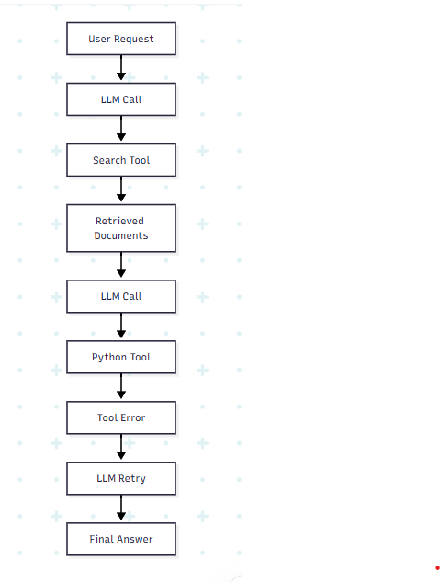
A tracing system can record:
- Prompts
- LLM calls
- Tool calls
- Retrieved information
- Errors
- Latency
- Token usage
- Intermediate outputs
A useful analogy from the article is:
Tracing is the flight recorder of an AI Agent.

5. Monitoring the Agent
Once an agent is deployed, development does not stop.
The system needs continuous monitoring.
For example, developers may monitor:
- Response quality
- Errors
- Latency
- Token usage
- Cost
- Tool failures
- Retrieval quality
- System reliability
This allows problems to be identified before they become larger operational issues.
6. The LLMOps Lifecycle
A typical lifecycle can be represented as:

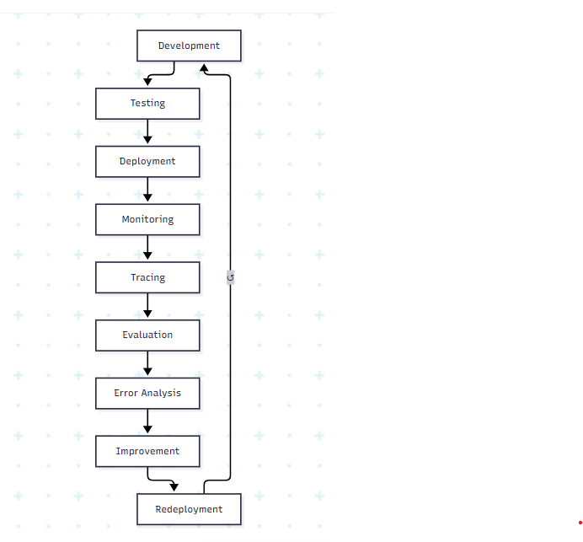
Notice that this is a continuous cycle.
The system is not simply built once and forgotten.
Instead:
Build → Test → Deploy → Observe → Evaluate → Improve → Deploy Again
This is one of the most important ideas in production AI systems.

7. Complete AI Agent Architecture
Now we can combine everything from the three parts.
A modern AI Agent can be viewed as:
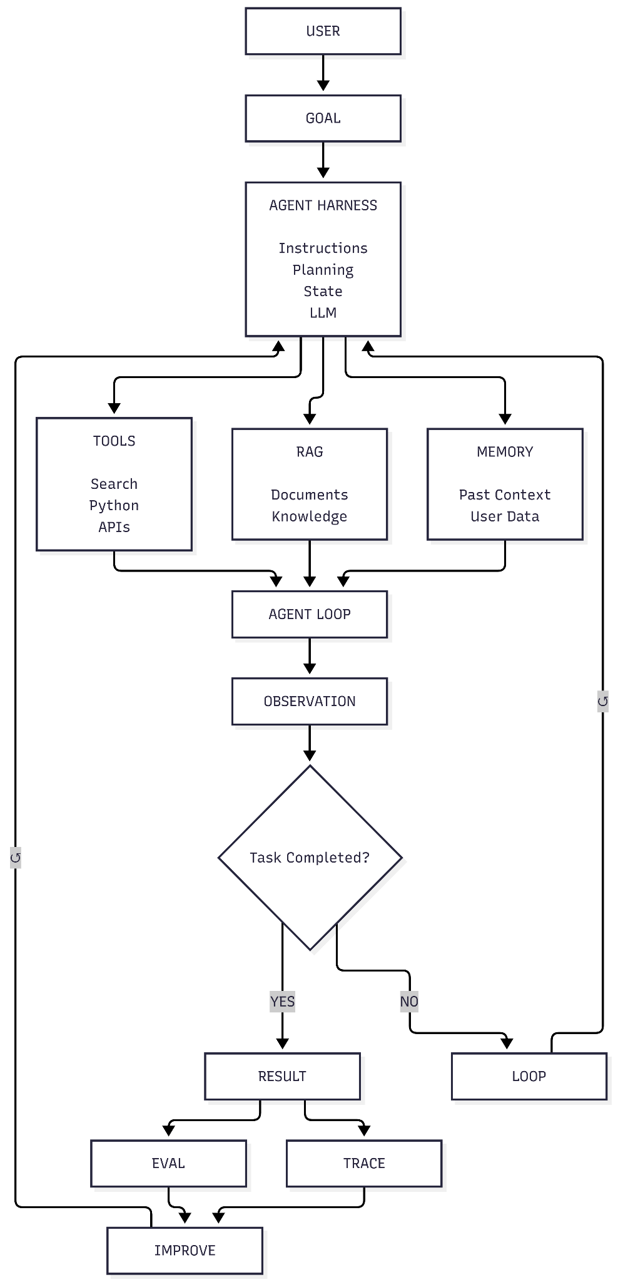
This demonstrates that an AI Agent is not a single component.
It is a collection of interconnected components working together.

8. A Practical Example: AI Research Agent
Let's put everything together with a practical example.
Suppose the user asks:
"Analyze recent research on AI across the Software Development Life Cycle and identify research gaps."
The agent can perform the following process.

Step 1 — Understand the Goal
The LLM identifies what the user is asking for.

Step 2 — Create a Plan
The agent creates a workflow:
Search → Retrieve → Read → Extract → Compare → Identify Gaps → Report

Step 3 — Search
The agent uses a search tool to find relevant papers.

Step 4 — Retrieve
RAG retrieves relevant papers and passages.

Step 5 — Extract
The agent extracts information such as:
- Research problem
- AI technique
- Dataset
- Methodology
- Results
- Limitations

Step 6 — Analyze
The agent compares the studies.

Step 7 — Check
The agent asks:
"Do I have enough evidence?"
If yes, it continues.
If no, it searches again.
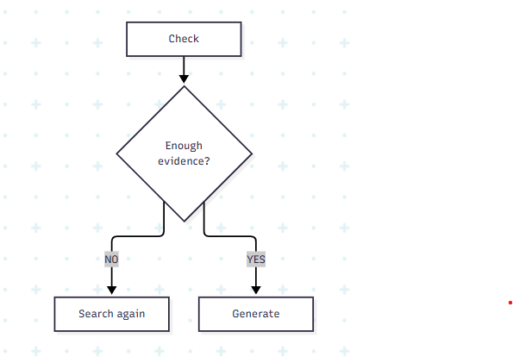

Step 8 — Generate
The agent creates:
- Literature summary
- Comparison table
- Research gaps
- References

Step 9 — Evaluate
Finally, the system checks whether the generated results meet predefined criteria.

9. The Complete Picture
After going through all three parts, we can summarize an AI Agent using one formula:
AI Agent = LLM + Tools + RAG + Memory + Planning + Agent Loop + Harness + Guardrails + Evaluation + Tracing + LLMOps

